# CYBER SECURITY 2ND ASSIGNMENT

Q1. Install Google chrome on a windows system

=>

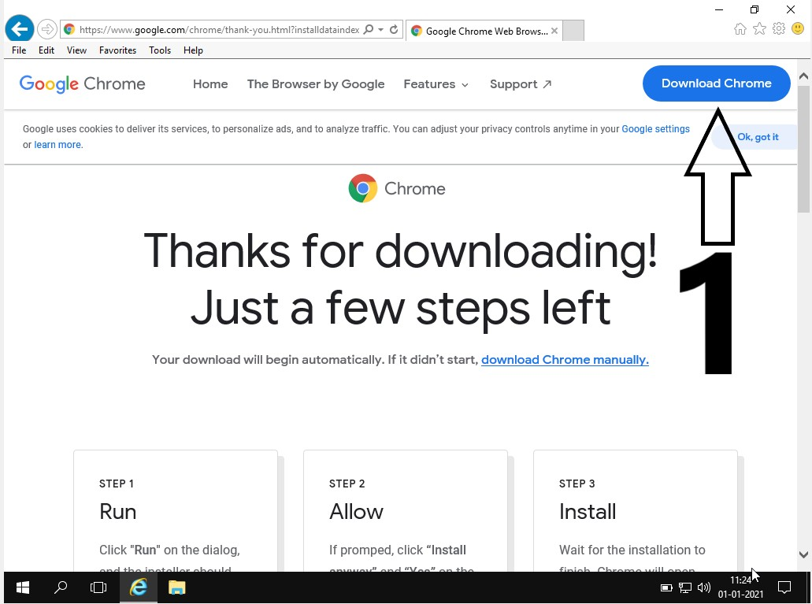

' ' ten

g g n

tn n t d t nd oo C o W b B 

File Edit View Favorites Tool s Help

Chrome

Get Chrome for Windows

For Windows 10/8.1/8/7 64bit.

Help make Google Chrome better by automatically sending usage statistics and crash reports to Google. Learn more

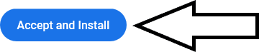By downloading Chrome, you agree to the Google Terms of Service and Chrome and Chrome OS Additional Terms of Service



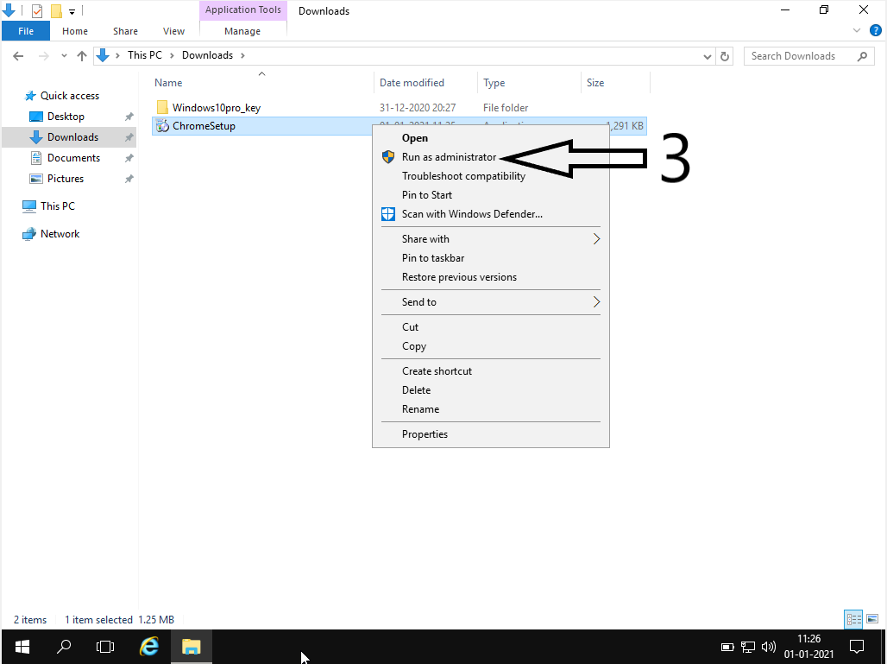

# Q2. Block the usage of google chrome to all users.

=>

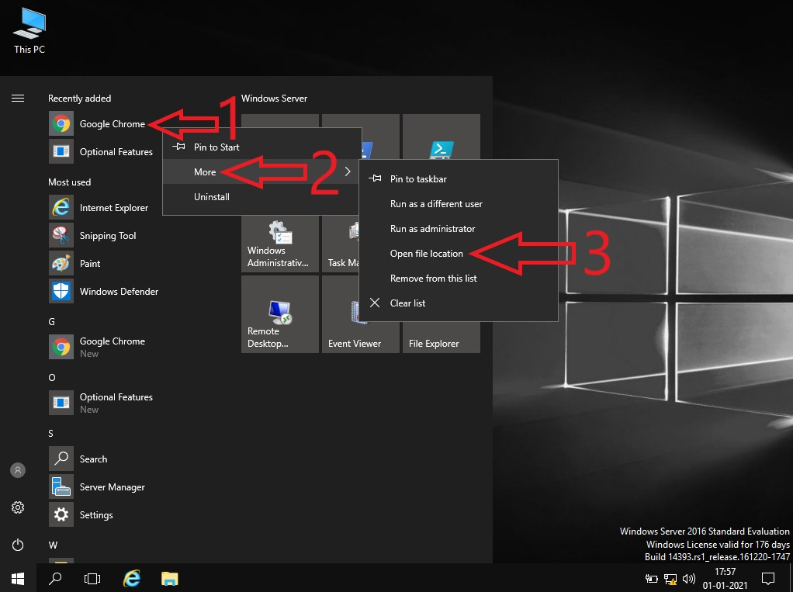



Shortcut Tools Application Tools pt gt#mg

0!

X

+ 0 » This PC » Local Disk (C:) » Program Data » Microsoft » Windows » Start Menu » Programs »

v Search Programs ,D



Desktop Download

B Documents





Network

Name

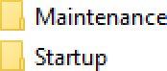

O windows Accessories

O winam Administrative Tools O winam m« of A«ess

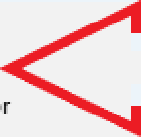

Print Dialog

Date modified 16-07-201618:53

16-07-201618:53

07-01-201708:55

16-07-201618:53

16-07-201618:53

16-07-201618:53

01-01-202111

16-07-201618

16-07-201618

Type

File folder File folder File folder File folder File folder File folder

Open file location Run as administrator

Size

Server IVlanager

16-07-201618

16-07-201618

Troubleshoot compatibility PIN tO Start

Scan with Windows Defender... Pin to taskbar

Restore previous versions Send tO

Cut C°Ry

Create shortcut Delete

Rename



11 items 1 item selected 2.26 KB

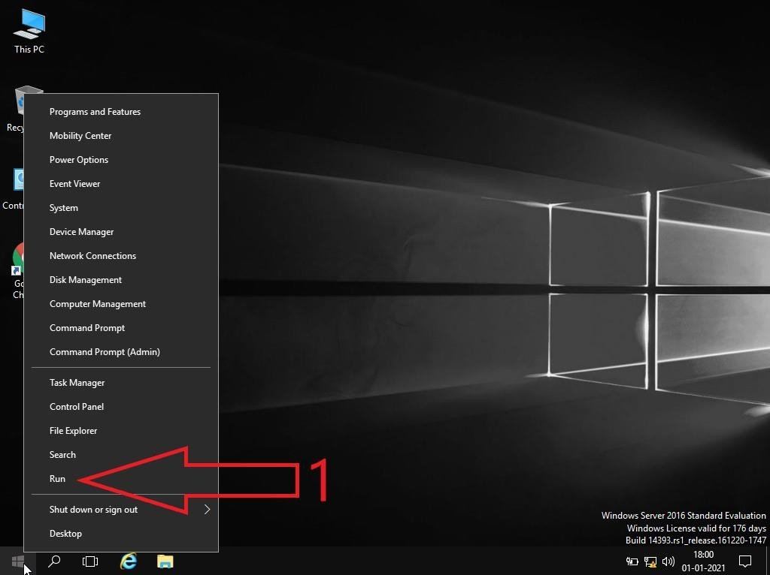

_‘ Local Group Policy Editor File Action View Help

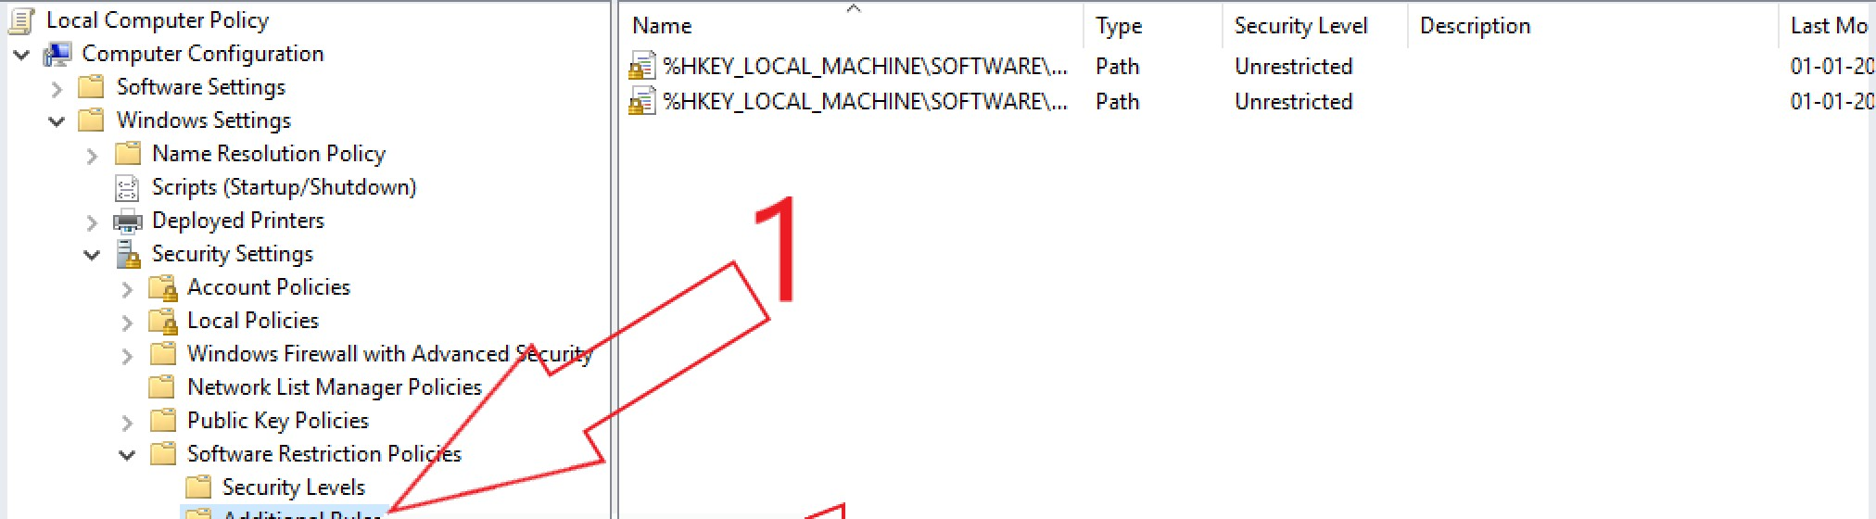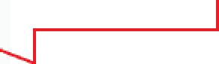

‘ Local Computer Policy

v @ Computer Configuration

Software Settings

v Windows Settings

Name Resolution Policy Scripts (Startup..’Shutdown)

m Deployed Printers v @ Security Settings

¿ Account Policies

¿ Local Policies

Windows Firewall with Advanced Network List Manager Policies

Name

Type

Security Level

Unrestricted Unrestricted

Description

ââHKEY LOCAL MACHINE\SOFTWARE\... Path

ââHKEY LOCAL MACHINE\SOFTWARE\... Path

Last Mo

01-01-2C

01-01-2C

ur”

v

Software Restriction Poli Security Levels Additional Rules

Applic ation Contra

IP Security Policies Advanced Audit Pa

New C ertific ate Rule...

New Hash Rule...

New Network ZoneRQ

New Path Rule...

”

'

g Policy- based QoS Administrative Templates

v t8. User Configuration

Software Settings Windows Settings Administrative Templates

2

All Tasks

View

Refresh Export List...

Help

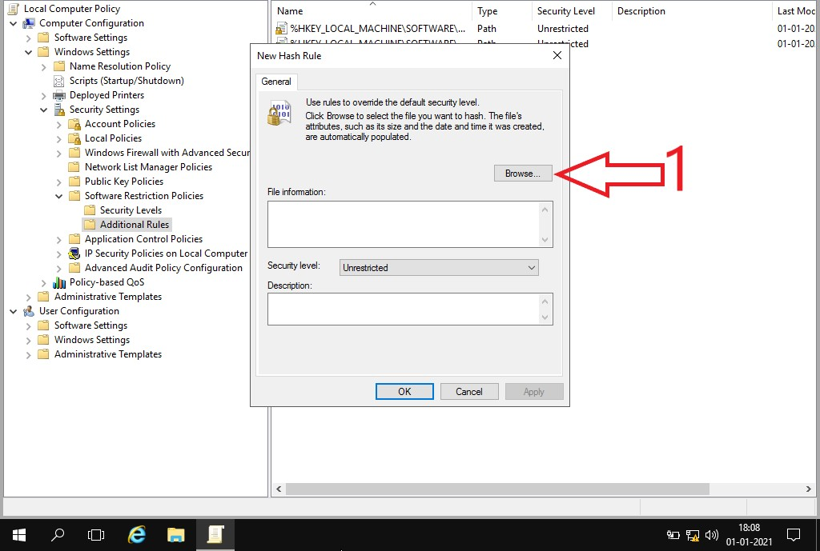File Action View Help



File Action View Help

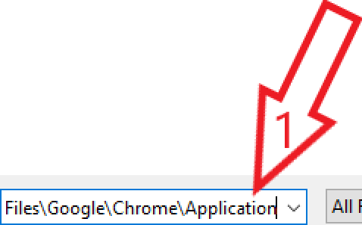

|  |
| --- |
| ‘ Local Computer Policy Name Type Security Level Description Last Mo v @ Computer Configuration ââHKEY LOCAL MACHINE\SOFTWARE\... Path Unrestricted 01-01-2(  _ Software Sett'^ 9* ’ ’--—*-icted 01-01-2(  v Windows Settings  Name Resolution Policy  Scripts (Startup..’Shutdown) _‘ Open m Deployed Printers  v @ Security Settings  ¿ Account Policies e  ¿ Local Policies  Windows Firewall with Advanced Secur'  Network List Manager Policies Fo lders  Desktop Devices and drives  v Software Restriction Policies  Security Levels Downloads Local Disk (C )  Additional Rules Documents  Applic ation C ontrol Policies w Pictures CD Drive (D:)  ' IP Security Policies on Local Computer SSS_X64FREEEN U  Advanced Audit Policy C onflgUFBttON EZ This PC aste file location  g Policy-based QoS  Administrative Templates Network    Software Settings Windows Settings  Administrative Templates 1  File name: Files\Google\Chrome\AppIic ation All FiIeS {*.\ |
|  |

 



File Action View Help

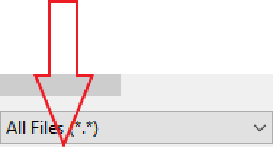

|  |  |  |  |  |
| --- | --- | --- | --- | --- |
|  | Local Computer Policy | Name Type Security Level Description  %HKEY LOCAL MACHINE\SOFTWARE\... Path Unrestricted  ~~“-'c~~ted  Open  +- + 0 « Chrome › Application › v Search Applic ation Organize • New folder  Name Date modified  Desktop O 87.0.4280.88 01-01-202111:30  SetupMetrics 01-01-202117:49  Downloads chrome 02-12-2020 07:31  B Documents chrome.VisuaIEIementsManifest 01-01-202111:30  *--* chrome proxy 02-12-2020 07:31  yg@ 01-01-202111:29  Network select chrome and open  File name: h o All *ñ* .*} |  | Last Moc |
| v | Computer Configuration  › @ Software Settings v @ Windows Settings |  | 04 -04 -20.  04 -04 -20. |
|  | › @ Name Resolution Policy |  |  |
|  | ; ; Scripts (Startup/Shutdown) |  |  |
|  | › Deployed Printers |  |  |
|  |  |  |  |
|  | › Account Policies  › Local Policies |  |  |
|  | › @ Windows Firewall with Advanced Secu | Type |  |
|  | @ Network List Manager Policies |  |  |
|  | › @ Public Key Policies | File folde |  |
|  | v @ Software Restriction Policies | File folde |  |
|  | @ Security Levels | Applicati |  |
|  | @ ArLfa@naI Ruks  › @ Application Control Policies  › ' IP Security Policies on Local Computer  › Advanced Audit Policy Configuration | XML Doc  Applicati File |  |
|  | › Policy-based QoS |  |  |
|  | › @ Administrative Templates |  |  |
|  | › @ Windows Settings |  |  |
|  | › @ Administrative Templates |  |  |
|  |  | • |  |
|  | | | | |

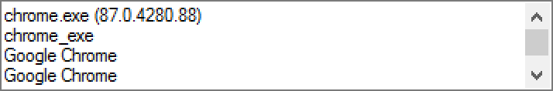@' Locai c oup Party £aao

*ñfie* Actin Ww Help

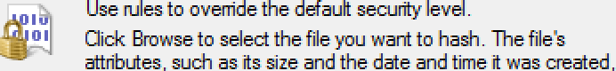

|  |  |  |  |
| --- | --- | --- | --- |
| Local Computer Policy  v Computer ConFqurat@n    › @ Name IfisoIut@n Port Scripts {Startup/Shutclo In)  › @ account Parma  › L+›cai Parma  › @ Windouzs Firewall with Advanced Secu @ hletwork Let k1a»ag<r Parma  › @ Pu6r< ray Parma  v @ Software Ifistrict@n Ports @ Secuñty Leveb  › @ Appr«atxsn Control Pores  › iP security Parvis on Local Computer  › @ aavaw<a a«ra Port co«rqurat@n  › Parry-l›as<a ozs  › @ Adminâtrative Templates v @ User ConFqurat@n  › @ Adminâtrative Templates | @ %HKFV_LOCAL_MACHINE\SOFTWARE\... Path  hfmx Flash Rule    ”    3 | Secuñty Level Unustricted    1 | Ehscript@n    2 |
|  | | | |

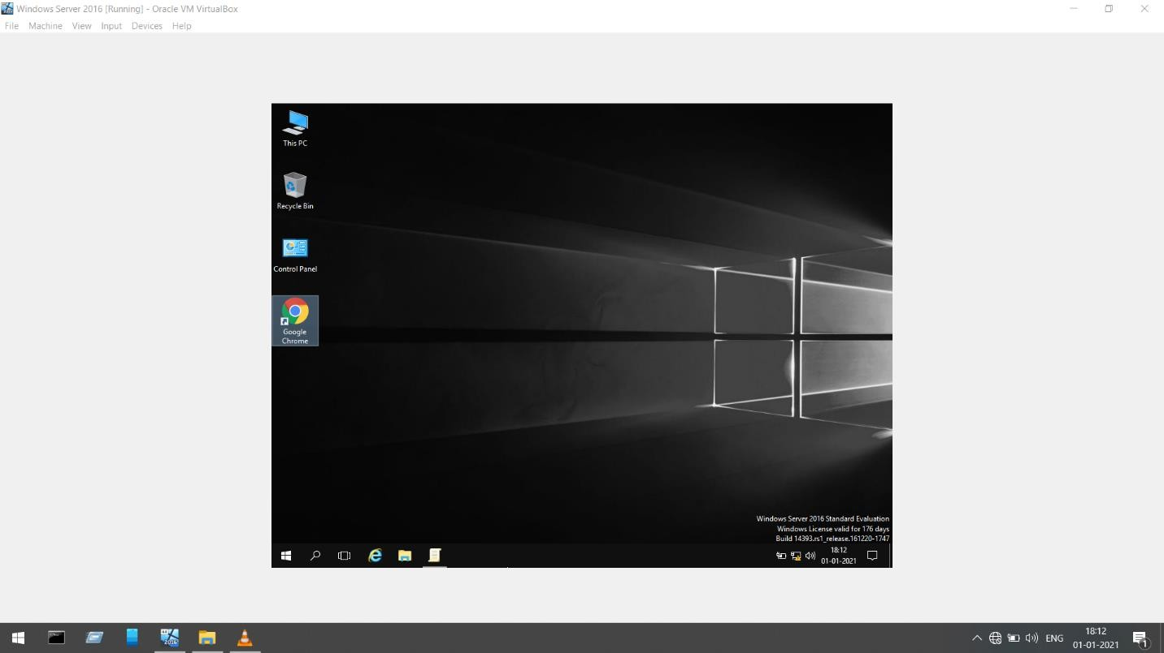



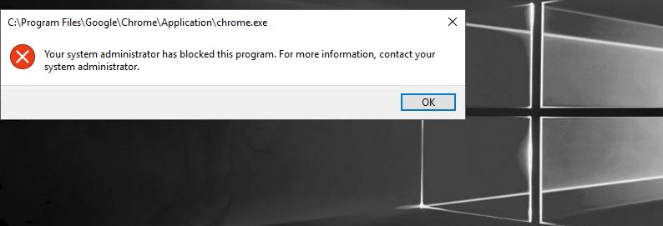



:

*e* m r

# Q3. Block the access of control panel to all the users in windows system

=>

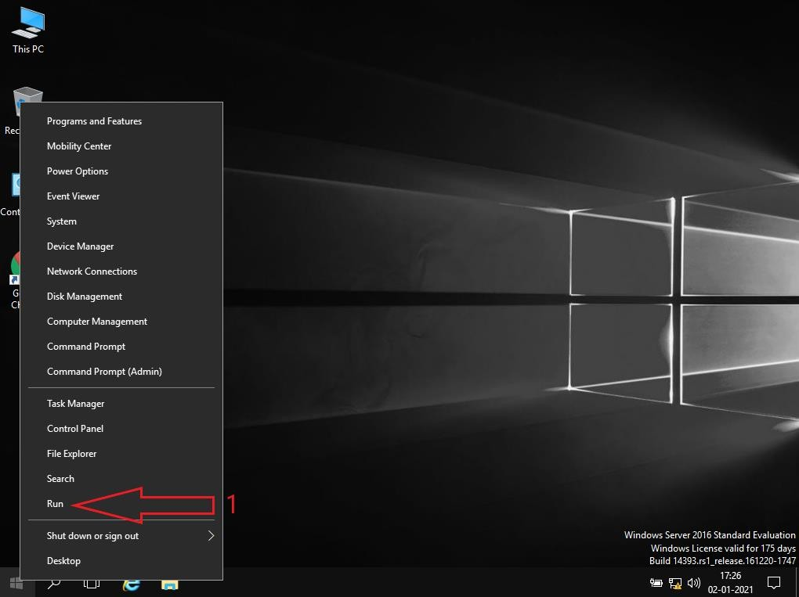

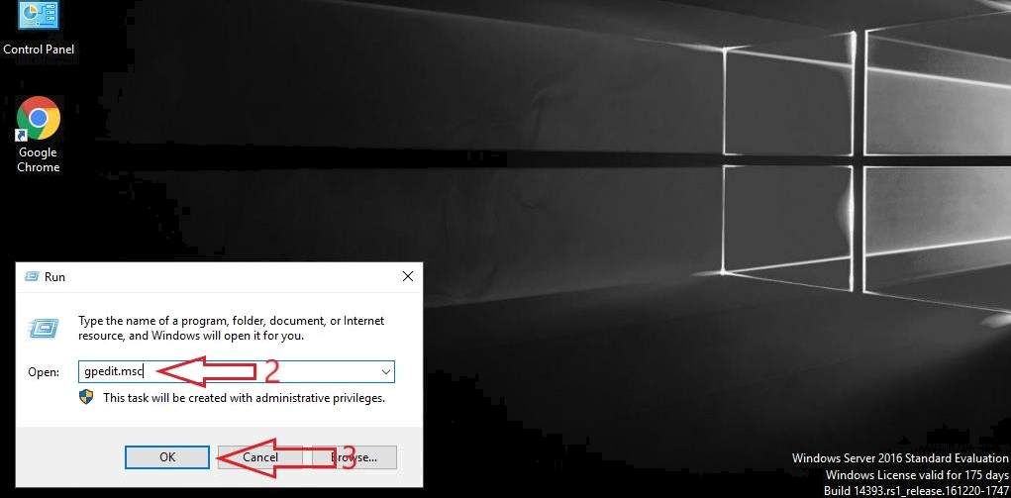

@/

/y) 17:27

_‘ Local Group Policy Editor  File Action View Help

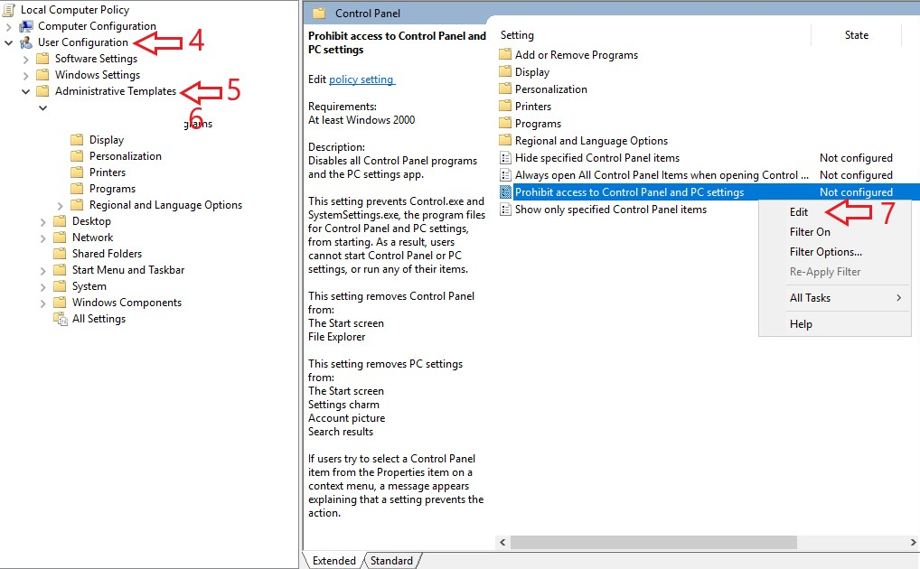

Control Panel

Add or Remo row



File Action View Help

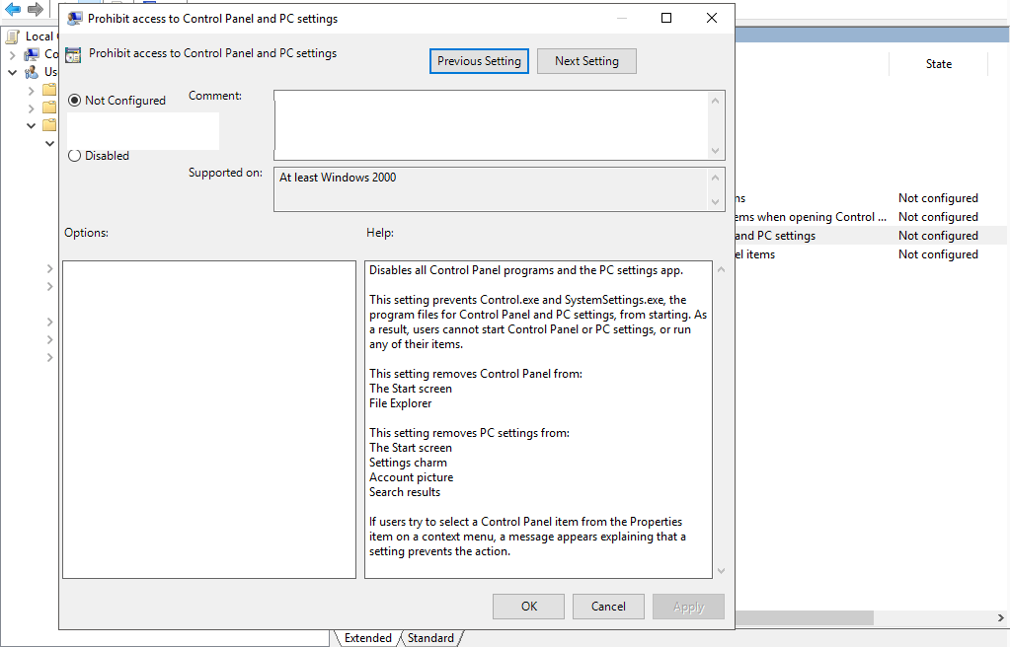

O Enabted

8



File Action View Help

|  |  |  |
| --- | --- | --- |
| Prohibit access to C ontrol Panel and PC settings |  | |
| Prohibit access to Control Panel and PC settings Previous Setting Next Setting  O M°tConWgured " omment:  O• Ena bled O Disa bled  Supported on As i art w+dowr 2000  Options: Help:  Disab let all C antrol P an el pro gram s and the PC settin gs app.  This setting prevents Control.ae and System Settings.ay the program files for C ontrol Panel and PC settings, from starting. As a result, users cannot start C ontrol Panel or PC settings, or run any of their items.  This setting removes C ontrol Panel from:  The Start screen File Explorer  This setting removes PC settings from:  The Start screen Settings charm  Account picture 9  Search results 10  If users try to select trol Pan from the Pro ies item on a context me a messag ppears aplaining at a setting prevents the acti .  Cancel Appl,’ |  | State |
| ns | Not configured |
| *me when opening C ontrol ... | Not configured |
| and PC settings | Not configured |
| el items | Not configured |

'

Local @ c

” —

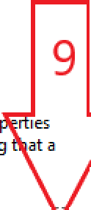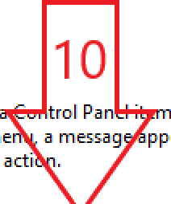

\ Extended Standard /



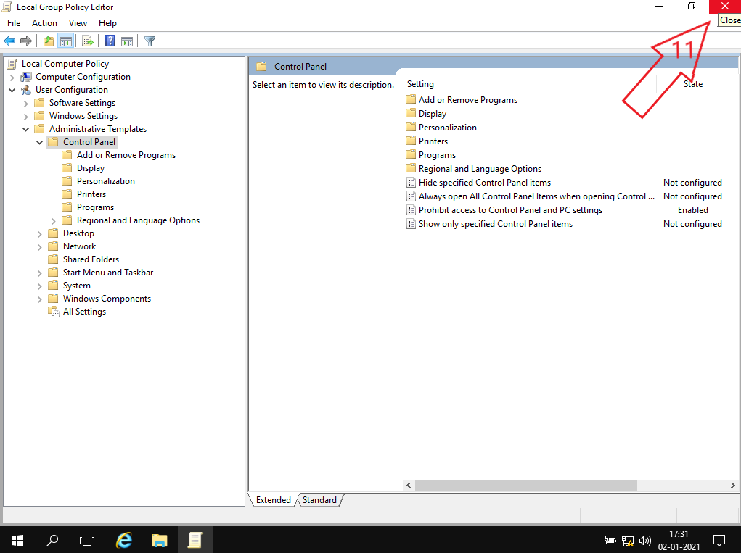



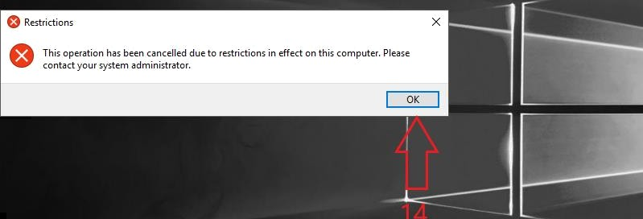



Wind own Never 701b bland ard dealua hon



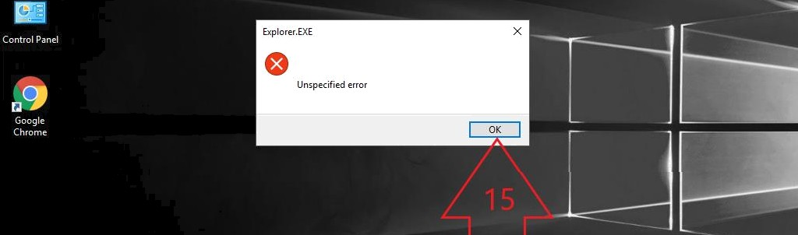



Wind ow Never 201b bland ard dealua hon

